SQL Assignment 6

Using special Operators in Conditions.

Q1) Write two different queries that would produce all orders taken on october 3 or 4 1990.

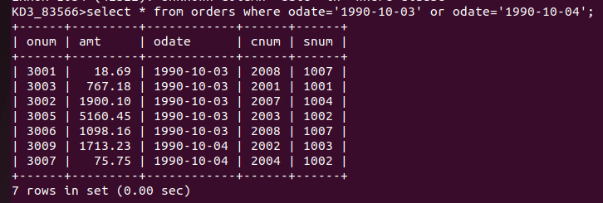
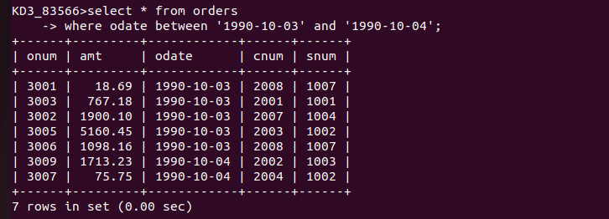

Q2) Write a query that selects all of the customers serviced by peel or motika. (Hint. The sum field relates the two tables to one another)

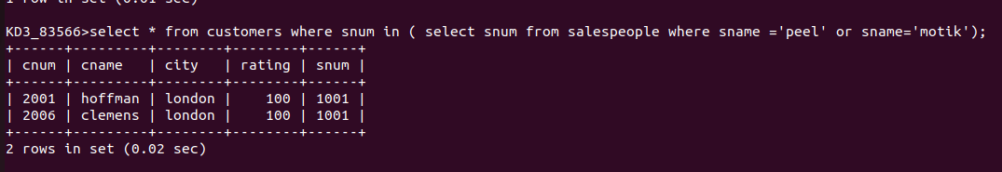

Q3) Write a query that will produce all the customers whose names begins with a letter from ‘A’ to ‘G’.

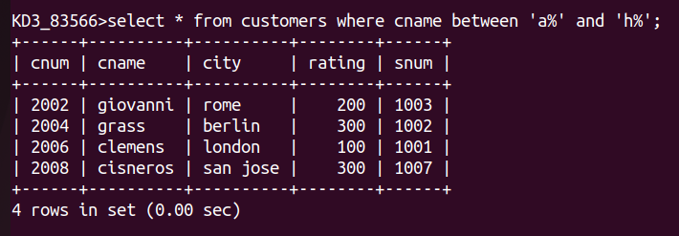

Q4) Write a query that selects all customers whose names begin with the letter ‘C’.


Q5) Write a query that selects all orders except those with zeros or nulls in the amt field.

